Chapter
Short-Term Scheduling

Discussion Questions
1. Scheduling’s objective is to optimize the use of resources so that production objectives are met.
2. Four criteria for scheduling are: minimizing completion time, maximizing utilization, minimizing work-in-process inventory, and minimizing customer waiting time. There is a one-to-one correspondence between minimizing completion time and mini-mizing flowtime.
3. Loading is the assignment of jobs to work processing centers. Work centers can be loaded by capacity or by assigning specific jobs to specific work centers. Gantt charts and the assignment method are loading techniques.
4. Five priority sequencing rules are:
- First come, first served (FCFS); or First in, first out (FIFO): Jobs are sequenced in the order in which they arrive at the workstation.
- Earliest due date (EDD): Jobs are sequenced in the order in which they are due for delivery to the customer.
- Shortest processing time (SPT): Jobs are sequenced in order of the processing time required at the workstation, with the job requiring the least processing time at the workstation scheduled first.
- Longest processing time (LPT): Jobs are sequenced in order of the processing time required at the workstation, with the job requiring the longest processing time at the workstation scheduled first.
- Critical ratio (CR): Jobs are sequenced in order of increasing critical ratio (the ratio of time required by work left to be done to time left to do the work).
5. SPT minimizes the average flow time, average lateness, and average number of jobs in the system. It maximizes the number of jobs completed at any point. The disadvantage is that long jobs are pushed back in the schedule.
6. A due date may range from a (meaningless) promise to a contractual obligation. It is a target with or without penalties.
7. Flow time is the length of time a job is in the system; lateness is completion time minus due date.
8. Most students will go for EDD, to gain minimum lateness. Others will go for SPT, on the grounds that the team can’t afford to tackle a job with an early due date and a long processing time. Interesting to see student assumption about sequence, damage, etc.
9. Johnson’s rule is used to sequence several jobs through two work centers.
10. Four effectiveness measures for dispatching rules: average completion time, average number of jobs in the system, average job lateness, and utilization.
11. The assignment method involves adding and subtracting appropriate numbers in the problem’s table in order to find the lowest opportunity cost for each assignment. The four steps are detailed in the chapter.
12. Advantages of level material use are:
- Lower inventory costs
- Faster product throughput (shorter lead times)
- Improved component and product quality
- Reduced floor space requirement
- Improved communication between employees because they are closer together
- A smoother production process because large lots have no hidden problems
13. Input/output control keeps track of planned versus actual in-puts and outputs, highlighting deviations and indicating bottlenecks.

Ethical Dilemma
Students may not be aware of the issue from an employee’s or employer’s perspective, but scheduling the “graveyard” shift and achieving performance on the graveyard shift can be a problem under the best of circumstances.
Rotating shifts is very difficult and the shorter the rotation cycle the worse—a one-week cycle is a killer. Given the box the manager has gotten into, the manager may want to let the empowered employees move to a one-week rotation and simulta-neously begin an education effort. The combination should result in the employees soon voting for a change to a more reasonable and intelligent schedule.
As long as the manager is doing his best to educate the employees and the short-term rotation does not last long, we see no significant ethical problem.
Not making employees aware of the literature and acquie-scing to a one-week schedule does suggest an unethical position.
Active Model Exercise
Active Model 15.1: Job Shop Sequencing
1. Which schedule (rule) minimizes the average completion time, maximizes the utilization and minimizes the average number of jobs in the system for this example?
SPT
2. Use the scrollbar to change the processing time for job C and use the scrollbar to modify the due date for job C. Does the same rule always minimize the average completion time?
Yes—SPT always minimizes the average completion time, maximizes utilization, and minimizes the average number of jobs in the system.
3. Which schedule (rule) minimizes the average lateness for this example?
EDD
4. Use the scrollbar to change the due date for job C. Does the same rule always minimize the average lateness?
No—if the due date for job C is 5, then FCFS and SPT minimize the average lateness.
End-of-Chapter Problems
15.1 (a) Gantt scheduling chart:

(b) Gantt load chart:
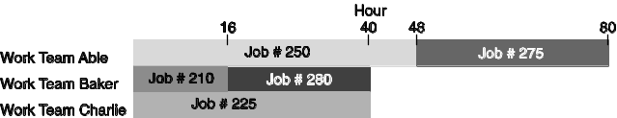

15.2
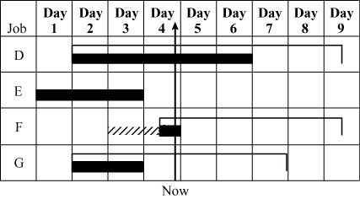
15.3 Original problem:

Site/Customer | A | B | C | D
1 | 7 | 3 | 4 | 8
2 | 5 | 4 | 6 | 5
3 | 6 | 7 | 9 | 6
4 | 8 | 6 | 7 | 4
Row subtraction is done next:
Site/Customer | A | B | C | D
1 | 4 | 0 | 1 | 5
2 | 1 | 0 | 2 | 1
3 | 0 | 1 | 3 | 0
4 | 4 | 2 | 3 | 0
Column subtraction is done next:
Site/Customer | A | B | C | D
1 | 4 | 0 | 0 | 5
2 | 1 | 0 | 1 | 1
3 | 0 | 1 | 2 | 0
4 | 4 | 2 | 2 | 0
Cover zeros with lines:
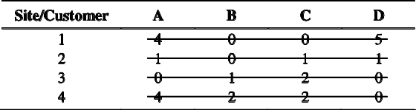

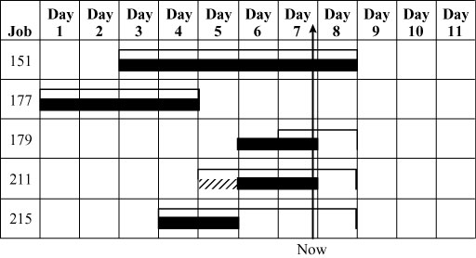

Optimal assignment:
Taxi at post 1 to customer C
Taxi at post 2 to customer B
Taxi at post 3 to customer A
Taxi at post 4 to customer D
Total distance traveled = 4 + 4 + 6 + 4 = 18 miles.
15.4 (a)
Original data
Job/Machine | A | B | C | D
1 | 7 | 8 | 8 | 10
2 | 10 | 9 | 7 | 6
3 | 11 | 5 | 9 | 6
4 | 9 | 11 | 5 | 8
First, we create a minimizing table by subtracting every number from 11
Job/Machine | A | B | C | D
1 | 4 | 2 | 3 | 1
2 | 1 | 2 | 4 | 5
3 | 0 | 6 | 2 | 5
4 | 2 | 0 | 6 | 3
then we do row subtraction:
Job/Machine | A | B | C | D
1 | 3 | 1 | 2 | 0
2 | 0 | 1 | 3 | 4
3 | 0 | 6 | 2 | 5
4 | 2 | 0 | 6 | 3
then we do column subtraction:
Job/Machine | A | B | C | D
1 | 3 | 1 | 0 | 0
2 | 0 | 1 | 1 | 4
3 | 0 | 6 | 0 | 5
4 | 2 | 0 | 4 | 3
Because it takes four lines to cover all zeros, an optimal assignment can be made at zero squares.
Assignment:
Job | to | Machine
1 |  | D
2 |  | A
3 |  | C
4 |  | B

(b) Total production: 40 [= 10 + 10 + 9 + 11]
15.5
Assignment | Rating
C53 at plant 1 | 10 cents
C81 at plant 3 | 4 cents
D5 at plant 4 | 30 cents
D44 at plant 2 |  | 14 cents
Total manufacturing cost 58 cents

15.6 Convert the minutes into $:
 | Marketing | Finance | Operations | Human  Resources
Chris | $80 | $120 | $125 | $140
Steve | $20 | $115 | $145 | $160
Juana | $40 | $100 | $85 | $45
Rebecca | $65 | $35 | $25 | $75

The minimum-cost solution =
Chris Finance $120
Steve Marketing $20
Juana Human Resources $45
Rebecca Operations $25
$210
15.7 Original problem:
Squad\Case | A | B | C | D | E
1 | 14 | 7 | 3 | 7 | 27
2 | 20 | 7 | 12 | 6 | 30
3 | 10 | 3 | 4 | 5 | 21
4 | 8 | 12 | 7 | 12 | 21
5 | 13 | 25 | 24 | 26 | 8

(a) Row subtraction is done next:
Squad\Case | A | B | C | D | E
1 | 11 | 4 | 0 | 4 | 24
2 | 14 | 1 | 6 | 0 | 24
3 | 7 | 0 | 1 | 2 | 18
4 | 1 | 5 | 0 | 5 | 14
5 | 5 | 17 | 16 | 18 | 0

Column subtraction is done next:
Squad\Case | A | B | C | D | E
1 | 10 | 4 | 0 | 4 | 24
2 | 13 | 1 | 6 | 0 | 24
3 | 6 | 0 | 1 | 2 | 18
4 | 0 | 5 | 0 | 5 | 14
5 | 4 | 17 | 16 | 18 | 0

Cover zeros with lines:
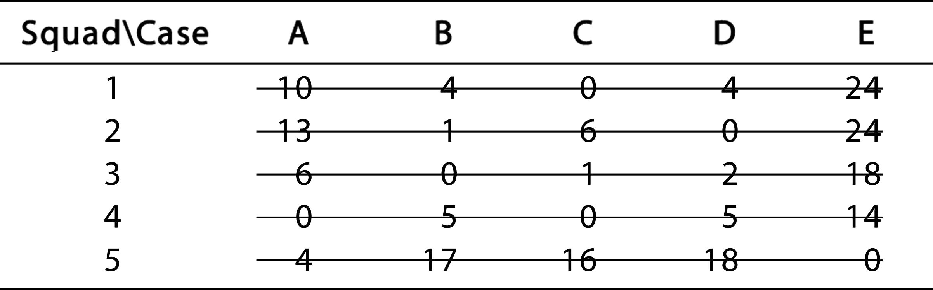
Optimal assignment:
Squad 1 to case C
Squad 2 to case D
Squad 3 to case B
Squad 4 to case A
Squad 5 to case E
Total person-days projected using this assignment = 3 + 6 +
3 + 8 + 8 = 28 days.
(b) We can avoid the assignment of squad 5 to case E occurring by assigning a very high value to that combination. In this case, we assign 50.
Problem:
Squad\Case | A | B | C | D | E
1 | 14 | 7 | 3 | 7 | 27
2 | 20 | 7 | 12 | 6 | 30
3 | 10 | 3 | 4 | 5 | 21
4 | 8 | 12 | 7 | 12 | 21
5 | 13 | 25 | 24 | 26 | 50

Row subtraction is done next:
Squad\Case | A | B | C | D | E
1 | 11 | 4 | 0 | 4 | 24
2 | 14 | 1 | 6 | 0 | 24
3 | 7 | 0 | 1 | 2 | 18
4 | 1 | 5 | 0 | 5 | 14
5 | 0 | 12 | 11 | 13 | 37

Column subtraction is done next:
Squad\Case | A | B | C | D | E
1 | 11 | 4 | 0 | 4 | 10
2 | 14 | 1 | 6 | 0 | 10
3 | 7 | 0 | 1 | 2 | 4
4 | 1 | 5 | 0 | 5 | 0
5 | 0 | 12 | 11 | 13 | 23

Cover zeros with lines:
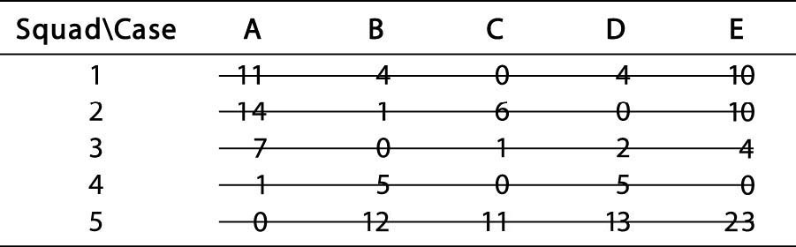

Optimal assignment:
Squad 1 to case C
Squad 2 to case D
Squad 3 to case B
Squad 4 to case E
Squad 5 to case A
Total person-days projected using this assignment = 3 + 6 +
3 + 21 + 13 = 46.
15.8
Original data:
 | Barbara | Dona | Stella | Jackie
Raul | 30 | 20 | 10 | 40
Jack | 70 | 10 | 60 | 70
Gray | 40 | 20 | 50 | 40
Ajay | 60 | 70 | 30 | 90
Create the minimizing table by subtracting every number from 90:
 | Barbara | Dona | Stella | Jackie
Raul | 60 | 70 | 80 | 50
Jack | 20 | 80 | 30 | 20
Gray | 50 | 70 | 40 | 50
Ajay | 30 | 20 | 60 | 0
Row subtraction:
 | Barbara | Dona | Stella | Jackie
Raul | 10 | 20 | 30 | 0
Jack | 0 | 60 | 10 | 0
Gray | 10 | 30 | 0 | 10
Ajay | 30 | 20 | 60 | 0
Column subtraction:
 | Barbara | Dona | Stella | Jackie
Raul | 10 | 0 | 30 | 0
Jack | 0 | 40 | 10 | 0
Gray | 10 | 10 | 0 | 10
Ajay | 30 | 0 | 60 | 0

Because it takes four lines to cover all zeros, an optimal assignment can be made at zero squares.
Note also that there are alternative optimal solutions.
The best pairs are assigned as follows:
Ajay—Jackie
Jack—Barbara
Gray—Stella
Raul—Dona
Total compatibility score (overall) = 90 + 70 + 50 + 20
= 230
15.9 Because this is a maximization problem, each number is subtracted from 95. The problem is then solved using the minimization algorithm.
(a)
Original data:
 | Statistics | Management | Finance | Economics
Fisher | 90 | 65 | 95 | 40
Golhar | 70 | 60 | 80 | 75
Hug | 85 | 40 | 80 | 60
Rustagi | 55 | 80 | 65 | 55
Create the minimizing table by subtracting every number from 95:
 | Statistics | Management | Finance | Economics
Fisher | 5 | 30 | 0 | 55
Golhar | 25 | 35 | 15 | 20
Hug | 10 | 55 | 15 | 35
Rustagi | 40 | 15 | 30 | 40
Row subtraction:
 | Statistics | Management | Finance | Economics
Fisher | 5 | 30 | 0 | 55
Golhar | 10 | 20 | 0 | 5
Hug | 0 | 45 | 5 | 25
Rustagi | 25 | 0 | 15 | 25
Column subtraction:
 | Statistics | Management | Finance | Economics
Fisher | 5 | 30 | 0 | 50
Golhar | 10 | 20 | 0 | 0
Hug | 0 | 45 | 5 | 20
Rustagi | 25 | 0 | 15 | 20

Because it takes four lines to cover all zeros, an optimal assignment can be made at zero squares.

Assignment | Rating
Fisher—finance | 95
Golhar—economics | 75
Hug—statistics | 85
Rustagi—management | 80
Total rating | 335

(b) Since Fisher is not teaching statistics, the answer does not change. Total rating remains 335.

15.10
Job | Due Date | Duration (Days)
A | 313 | 8
B | 312 | 16
C | 325 | 40
D | 314 | 5
E | 314 | 3

FCFS
Job | Due Date | Duration (days) | Flow | Start | End | Lateness
A | 313 | 8 | 8 | 275 | 282 | 0
B | 312 | 16 | 24 | 283 | 298 | 0
C | 325 | 40 | 64 | 299 | 338 | 13
D | 314 | 5 | 69 | 339 | 343 | 29
E | 314 | 3 | 72 | 344 | 346 | 32
Totals: |  | 72 | 237 |  |  | 74

EDD
Job | Due Date | Duration (days) | Flow | Start | End | Lateness
B | 312 | 16 | 16 | 275 | 290 | 0
A | 313 | 8 | 24 | 291 | 298 | 0
D | 314 | 5 | 29 | 299 | 303 | 0
E | 314 | 3 | 32 | 304 | 306 | 0
C | 325 | 40 | 72 | 307 | 346 | 21
Totals: |  | 72 | 173 |  |  | 21

SPT
Job | Due Date | Duration (days) | Flow | Start | End | Lateness
E | 314 | 3 | 3 | 275 | 277 | 0
D | 314 | 5 | 8 | 278 | 282 | 0
A | 313 | 8 | 16 | 283 | 290 | 0
B | 312 | 16 | 32 | 291 | 306 | 0
C | 325 | 40 | 72 | 307 | 346 | 22
Totals: |  | 72 | 131 |  |  | 22

LPT
Job | Due Date | Duration (days) | Flow | Start | End | Lateness
C | 325 | 40 | 40 | 275 | 314 | 0
B | 312 | 16 | 56 | 315 | 330 | 18
A | 313 | 8 | 64 | 331 | 338 | 25
D | 314 | 5 | 69 | 339 | 343 | 29
E | 314 | 3 | 72 | 344 | 346 | 32
Totals: |  | 72 | 301 |  |  | 104

(a) FCFS (first come, first served):
Because all jobs arrived on day 275, and presumably in the order given, the FCFS sequence is:
A, B, C, D, E

(b) EDD (earliest due date):
Job Sequence | Due Date
B | 312
A | 313
D | 314
E | 314
C | 325
(c) SPT (shortest processing time):
Job Sequence | Processing Time
E | 3
D | 5
A | 8
B | 16
C | 40
(d) LPT (longest processing time):
Job Sequence | Processing Time
C | 40
B | 16
A | 8
D | 5
E | 3

Scheduling | Average | Average | Average Number
Rule | Tardiness | Flow Time | of Jobs in System
FCFS | 14.8 | 47.4 | 3.3
EDD | 4.2* | 34.6 | 2.4
SPT | 4.2* | 26.2* | 1.8*
LPT | 20.8 | 60.2 | 4.2
* = Best

15.11 | Job | Due Date | Remaining Days | Critical Ratio
 | 103 | 214 | 10 | 1.40
 | 205 | 223 | 7 | 3.29
 | 309 | 217 | 11 | 1.55
 | 412 | 219 | 5 | 3.80
 | 517 | 217 | 15 | 1.13

Jobs should be scheduled in the sequence 517, 103, 309, 205, 412 if scheduled by the critical ratio scheduling rule.

15.12 |  |  | Remaining
 | Job | Due date | Processing Time
 | A | 212 | 6
 | B | 209 | 3
 | C | 208 | 3
 | D | 210 | 8
Minimize total lateness. Comparing the scheduling efficiency of the several algorithms presented in terms of lateness:
(a) First come, first served (FCFS):
Job | Processing  Time | Due  Date | Start | End | Days Late
A | 6 | 212 | 205 | 210 | 0
B | 3 | 209 | 211 | 213 | 4
C | 3 | 208 | 214 | 216 | 8
D | 8 | 210 | 217 | 224 |  | 14
 |  |  |  | Total: 26 days
(b) Shortest processing time (SPT):
Job | Processing  Time | Due  Date | Start | End | Days Late
B | 3 | 209 | 205 | 207 | 0
C | 3 | 208 | 208 | 210 | 2
A | 6 | 212 | 211 | 216 | 4
D | 8 | 210 | 217 | 224 |  | 14
 |  |  |  | Total: 20 days
(c) Longest processing time (LPT):
Job | Processing  Time | Due  Date | Start | End | Days Late
D | 8 | 210 | 205 | 212 | 2
A | 6 | 212 | 213 | 218 | 6
C | 3 | 208 | 219 | 221 | 13
B | 3 | 209 | 222 | 224 |  | 15
 |  |  |  | Total: 36 days
(d) Earliest due date (EDD):
Job | Processing  Time | Due  Date | Start | End | Days Late
C | 3 | 208 | 205 | 207 | 0
B | 3 | 209 | 208 | 210 | 1
D | 8 | 210 | 211 | 218 | 8
A | 6 | 212 | 219 | 224 |  | 12
 |  |  |  | Total: 21 days
(e) Critical ratio:
Job | Due  Date | Remaining  Processing  Time | Critical Ratio
A | 212 | 6 | (212 – 205)/6 = 1.17
B | 209 | 3 | (209 – 205)/3 = 1.33
C | 208 | 3 | (208 – 205)/3 = 1.00
D | 210 | 8 | (210 – 205)/8 = 0.63
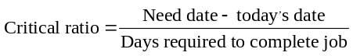

Job Sequence | Critical Ratio
D | 0.63
C | 1.00
A | 1.17
B | 1.33

Critical ratio:
Job | Processing  Time | Due  Date | Start | End | Days Late
D | 8 | 210 | 205 | 212 | 2
C | 3 | 208 | 213 | 215 | 7
A | 6 | 212 | 216 | 221 | 9
B | 3 | 209 | 222 | 224 |  | 15
 |  |  |  | Total: 33 days
A minimum total lateness of 20 days seems to be about the least we may achieve.
 |  |  | Average
 |  |  | Number
Scheduling | Average | Average | of Jobs in
Rule | Lateness | Flow Time | System
FCFS | 6.5 | 11.8 | 2.4
SPT | 5.0 | 10.25 | 2.1
LPT | 9.0 | 14.8 | 3.0
EDD | 5.25 | 10.8 | 2.2
Critical ratio | 8.3 | 14.0 | 2.8
SPT is best on all criteria.
15.13 (a)
Dispatching  Rule | Job Sequence | Flow Time | Utilization | Average Number  of Jobs | Average Late
EDD | CX–BR–SY–DE–RG | 385 | 37.6% | 2.66 | 10
SPT | BR–CX–SY–DE–RG | 375 | 38.6% | 2.59 | 12
LPT | RG–DE–SY–CX–BR | 495 | 29.3% | 3.41 | 44
FCFS | CX–BR–DE–SY–RG | 390 | 37.2% | 2.69 | 12
Starting day number: 241 (i.e., work can be done on day 241)
Method: SPT—Shortest processing time
 | Processing Time |  |  | Due Date | Order | Flow Time |  |  | Completion  Time | Late
CX-01 | 25 |  |  | 270 | 2 | 40 |  |  | 280 | 10
BR-02 | 15 |  |  | 300 | 1 | 15 |  |  | 255 | 0
DE-06 | 35 |  |  | 320 | 4 | 105 |  |  | 345 | 25
SY-11 | 30 |  |  | 310 | 3 | 70 |  |  | 310 | 0
RG-05 |  | 40 |  | 360 | 5 |  | 145 |  | 385 |  | 25
Total | 145 |  |  |  |  | 375 |  |  |  | 60
Average |  |  |  |  |  | 75 |  |  |  | 12
Sequence: BR-02,CX-01,SY-11,DE-06,RG-05 Average # in system = 2.586 = 375/145

Method: LPT—Longest processing time
 | Processing Time |  |  |  |  |  | Due Date |  | Order |  | Flow Time |  |  |  | Completion  Time |  |  |  | Late
CX-01 | 25 |  |  |  |  |  | 270 |  | 4 |  | 130 |  |  |  | 370 |  |  |  | 100
BR-02 | 15 |  |  |  |  |  | 300 |  | 5 |  | 145 |  |  |  | 385 |  |  |  | 85
DE-06 | 35 |  |  |  |  |  | 320 |  | 2 |  | 75 |  |  |  | 315 |  |  |  | 0
SY-11 | 30 |  |  |  |  |  | 310 |  | 3 |  | 105 |  |  |  | 345 |  |  |  | 35
RG-05 |  |  | 40 |  |  |  | 360 |  | 1 |  |  | 40 |  |  | 280 |  |  |  |  |  | 0
Total | 145 |  |  |  |  |  |  |  |  |  | 495 |  |  |  |  |  |  |  | 220
Average |  |  |  |  |  |  |  |  |  |  | 99 |  |  |  |  |  |  |  | 44
Sequence: RG-05,DE-06,SY-11,CX-01,BR-02, Average # in system = 3.414 = 495/145
Method: Earliest due date (EDD); earliest to latest date
 |  | Processing Time |  |  |  |  |  | Due Date |  | Slack |  |  |  | Order |  | Flow Time |  |  |  | Completion Time |  |  |  | Late
CX-01 |  | 25 |  |  |  |  |  | 270 |  | 0 |  |  |  | 1 |  | 25 |  |  |  | 265 |  |  |  | 0
BR-02 |  | 15 |  |  |  |  |  | 300 |  | 0 |  |  |  | 2 |  | 40 |  |  |  | 280 |  |  |  | 0
DE-06 |  | 35 |  |  |  |  |  | 320 |  | 0 |  |  |  | 4 |  | 105 |  |  |  | 345 |  |  |  | 25
SY-11 |  | 30 |  |  |  |  |  | 310 |  | 0 |  |  |  | 3 |  | 70 |  |  |  | 310 |  |  |  | 0
RG-05 |  |  |  |  | 40 |  |  | 360 |  | 0 |  |  |  | 5 |  |  | 145 |  |  | 385 |  |  |  |  | 25
Total |  | 145 |  |  |  |  |  |  |  |  |  |  |  |  |  | 385 |  |  |  |  |  |  |  | 50
Average |  |  |  |  |  |  |  |  |  |  |  |  |  |  |  | 77 |  |  |  |  |  |  |  | 10
Sequence: CX-01,BR-02,SY-11,DE-06,RG-05 Average # in system = 2.655 = 385/145
Method: First come, first served (FCFS)
 |  | Processing Time |  |  |  |  |  | Due Date |  | Slack |  |  |  | Order |  | Flow Time |  |  |  | Completion Time |  |  |  | Late
CX-01 |  | 25 |  |  |  |  |  | 270 |  | 0 |  |  |  | 1 |  | 25 |  |  |  | 265 |  |  |  | 0
BR-02 |  | 15 |  |  |  |  |  | 300 |  | 0 |  |  |  | 2 |  | 40 |  |  |  | 280 |  |  |  | 0
DE-06 |  | 35 |  |  |  |  |  | 320 |  | 0 |  |  |  | 3 |  | 75 |  |  |  | 315 |  |  |  | 0
SY-11 |  | 30 |  |  |  |  |  | 310 |  | 0 |  |  |  | 4 |  | 105 |  |  |  | 345 |  |  |  | 35
RG-05 |  |  |  |  | 40 |  |  | 360 |  | 0 |  |  |  | 5 |  |  | 145 |  |  | 385 |  |  |  |  | 25
Total |  | 145 |  |  |  |  |  |  |  |  |  |  |  |  |  | 390 |  |  |  |  |  |  |  | 60
Average |  |  |  |  |  |  |  |  |  |  |  |  |  |  |  | 78 |  |  |  |  |  |  |  | 12
Sequence: CX-01,BR-02,DE-06,SY-11,RG-05, Average # in system = 2.69 = 390/145

(b) The best flowtime is SPT; (c) best utilization is SPT;
(d) best lateness is EDD. (e) Students could support
either of these choices. LPT scores poorly on all three
criteria.
15.14
 | Job | Date  Order  Received | Production  Days  Needed | Date  Order  Due
 | A | 110 | 20 | 180
 | B | 120 | 30 | 200
 | C | 122 | 10 | 175
 | D | 125 | 16 | 230
 | E | 130 | 18 | 210

(a) FCFS (first come, first served):
Job Sequence | Date Order Received
A | 110
B | 120
C | 122
D | 125
E | 130

(b) EDD (earliest due date):
Job Sequence | Due Date
C | 175
A | 180
B | 200
E | 210
D | 230

(c) SPT (shortest processing time):
Job Sequence | Processing Time
C | 10
D | 16
E | 18
A | 20
B | 30

(d) LPT (longest processing time):
Job Sequence | Processing Time
B | 30
A | 20
E | 18
D | 16
C | 10

 |  |  | Average
 |  |  | Number
Scheduling | Average | Average | of Jobs in
Rule | Tardiness | Flow Time | System
FCFS | 5.4 | 60.0 | 3.2
EDD | 0.0 | 54.4 | 2.9
SPT | 7.2 | 47.6 | 2.5
LPT | 9.6 | 65.2 | 3.5
EDD is best for Average Lateness and SPT for the other two measures.
15.15
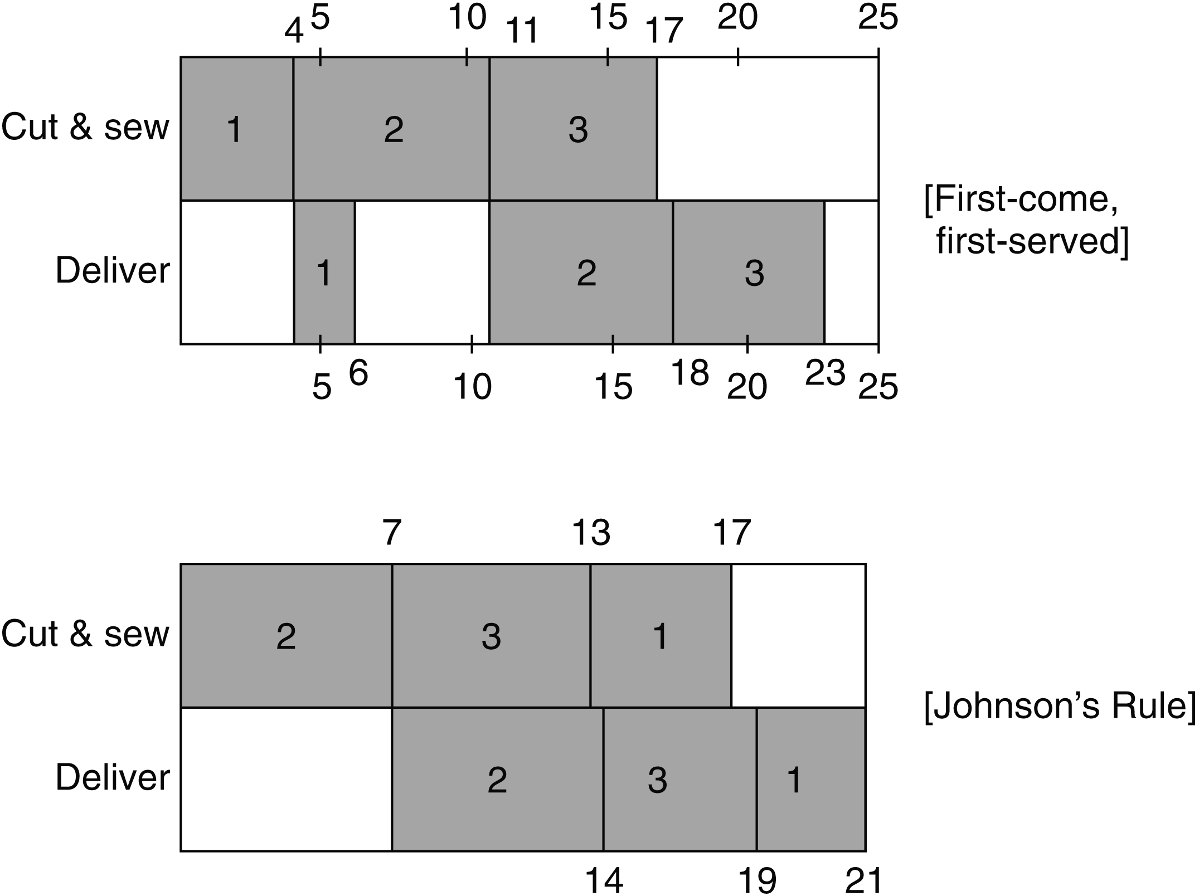
Johnson’s Rule finishes in 21 days, 2 days faster than the First-come, First-served schedule, which finishes in 23 days.
15.16
 | Date | Production | Date
 | Job | Days | Job | Critical
Job | Received | Needed | Due | Ratio
1 | 215 | 30 | 260 | 0.33
2 | 220 | 20 | 290 | 2.00
3 | 225 | 40 | 300 | 1.25
4 | 240 | 50 | 320 | 1.40
5 | 250 | 20 | 340 | 4.50
Jobs should be scheduled in the sequence 1, 3, 4, 2, 5 if scheduled by the critical ratio scheduling rule.

15.17 (a, c) The jobs should be processed in the sequence
V–Y–U–Z–X–W–T, for a total time of 57.
 | Job Shop Scheduling Flow Time
 | Printer | Binder | Order | Printer | Binder
T | 15 | 3 | seventh | 54 | 57
U | 7 | 9 | third | 15 | 28
V | 4 | 10 | first | 4 | 14
W | 7 | 6 | sixth | 39 | 51
X | 10 | 9 | fifth | 32 | 45
Y | 4 | 5 | second | 8 | 19
Z | 7 | 8 | fourth | 22 |  | 36
Time |  |  |  |  | 57

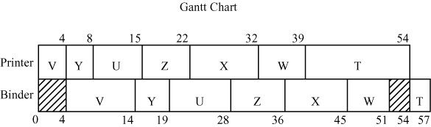
(b, c)

Note: Y could also be placed first, with no change in total times.
(d) Binding is idle from 0 to 4 and from 51 to 54 for a total of 7 hours.
(e) We split Job Z into two halves and call them Z₁ and Z₂. The times become 3.5 hours each on the Printer and 4 hours on the Binder.

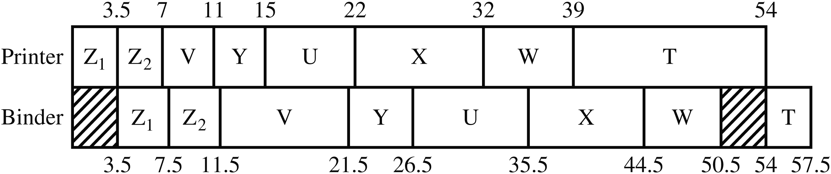

We see that the Binder idle time is now 3.5 hours plus 3.5 hours, for a total of 7 hours. So it is unchanged. T is not finished any sooner, but other jobs are completed ½ hour earlier.
15.18

Using Johnson’s rule, the optimal sequence is:
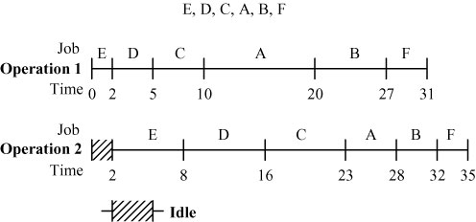

Job | Operation 1 (Hours) | Operation 2 (Hours)
A | 10 | 5
B | 7 | 4
C | 5 | 7
D | 3 | 8
E | 2 | 6
F | 4 | 3

15.19 |  | Monday | Tuesday | Wednesday | Thursday | Friday | Saturday | Sunday
 | Worker 1 | 6 | 5 | 5 | 5 | 6 | 4 | 3
 | Worker 2 | 5 | 4 | 4 | 4 | 5 | 4 | 3
 | Worker 3 | 4 | 3 | 3 | 3 | 4 | 4 | 3
 | Worker 4 | 3 | 3 | 3 | 2 | 3 | 3 | 2
 | Worker 5 | 2 | 2 | 2 | 1 | 2 | 3 | 2
 | Worker 6 | 1 | 1 | 2 | 1 | 1 | 2 | 1
 | Worker 7 | 1 | 1 | 1 | 0 | 0 | 1 | 0

Note: Seven employees are needed; six have two consecutive days off. The 7th worker has two consecutive days off but only works 4 days. Days off are circled.

15.21
15.20 |  | Monday | Tuesday | Wednesday | Thursday | Friday | Saturday | Sunday
 | Worker 1 | 3 | 4 | 4 | 5 | 6 | 7 | 4
 | Worker 2 | 3 | 3 | 3 | 4 | 5 | 6 | 4
 | Worker 3 | 3 | 3 | 2 | 3 | 4 | 5 | 3
 | Worker 4 | 2 | 3 | 2 | 2 | 3 | 4 | 2
 | Worker 5 | 1 | 2 | 2 | 2 | 2 | 3 | 1
 | Worker 6 | 1 | 1 | 1 | 1 | 1 | 2 | 1
 | Worker 7 | 1 | 0 | 0 | 0 | 0 | 1 | 1
 | Note: Seven employees are needed: six have two consecutive days off. The 7th worker has 4 days off and only works 3.
Period |  | 1 | 2 | 3 | 4 | Total
Planned input |  | 80 | 80 | 100 | 100 | 360
Actual input |  | 85 | 85 | 85 | 85 | 340
Deviation |  | +5 | +5 | –15 | –15 | –20
Planned output |  | 90 | 90 | 90 | 90 | 360
Actual output |  | 85 | 85 | 80 | 80 | 330
Deviation |  | –5 | –5 | –10 | –10 | –30
Backlog: 30 |  | 30 | 30 | 35 | 40
Analysis: The completed input/output report shows that the Grinding work center did not process all the jobs that were available during the four periods; therefore, the desired output rate was not achieved. Also, rather than reducing the backlog, the backlog increased to 40 units.

Additional Homework Problems*
15.22 (a) Assign:
Job | to | Machine
1 |  | A
2 |  | D
3 |  | B
4 |  | C
(b) Total cost: 23
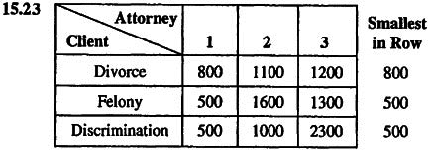

*Here are solutions to the additional homework problems that are located on our Web site, at www.myomlab.com.

Subtracting the smallest number from each row:

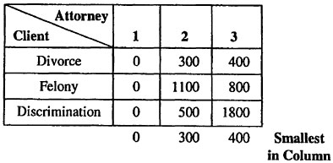
Subtracting the smallest number from each column:
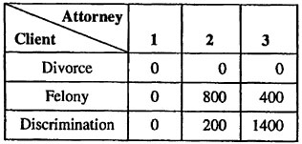
Draw the minimum number of lines needed to cover the zeros:
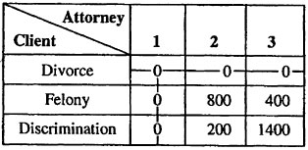

Subtracting the smallest uncovered number (200) from all uncovered numbers, and adding it to the numbers at the intersections of the lines:
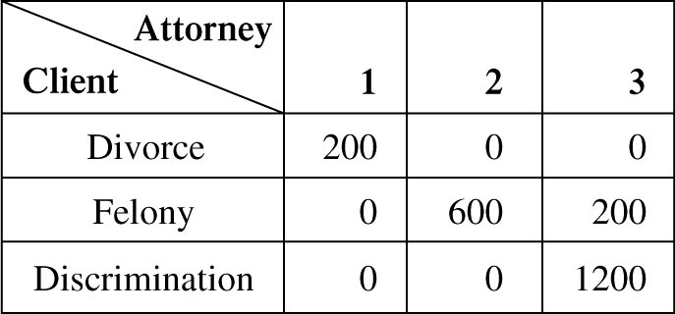
Again, draw the minimum number of lines needed to cover the zeros:
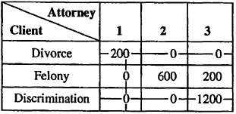
The solution is now optimal, and the assignments can be made in the following manner:
Assignment | Cost
Divorce case to Attorney 3 | 1200
Felony case to Attorney 1 | 500
Discrimination case to Attorney 2 |  | 1000
 | $2700

15.24 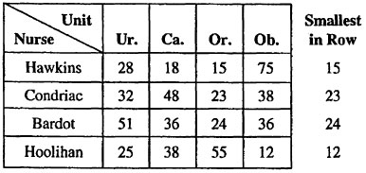

Subtracting the smallest number from each row:
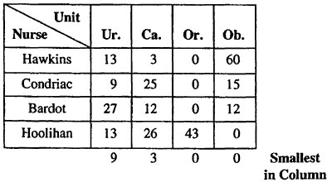

Subtracting the smallest number from every column:
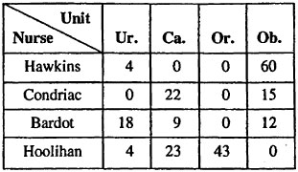

The following optimal assignments can now be made:
Assignments | Cost
Nurse Condriac to Urology | 32
Nurse Hawkins to Cardiology | 18
Nurse Bardot to Orthopedics | 24
Nurse Hoolihan to Obstetrics |  | 12
Total Cost: | 86

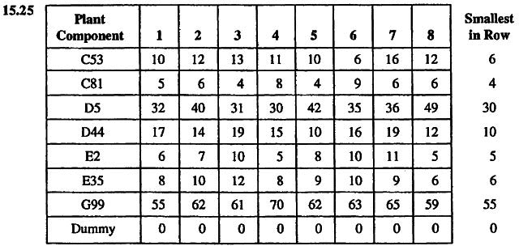

Subtracting the smallest number from every row:

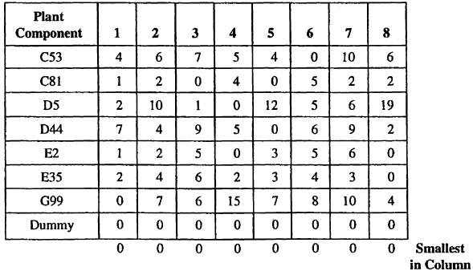

Draw the minimum number of lines needed to cover the
zeros:

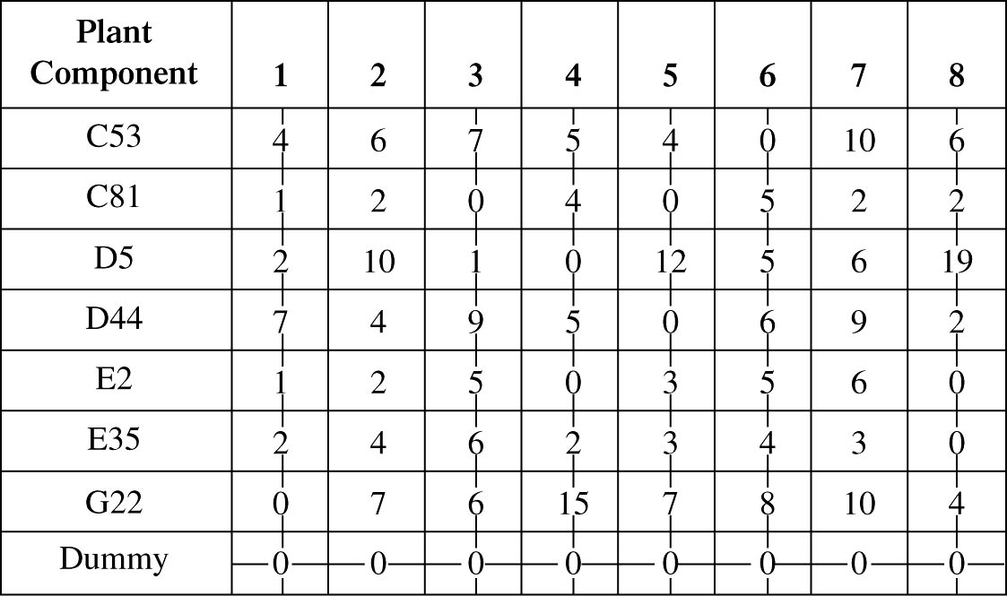

Subtracting the smallest uncovered number (2) from all
uncovered numbers, and adding it to the numbers at the
intersections of the lines:

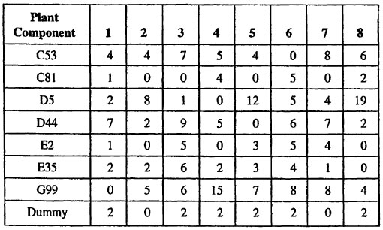

Draw the minimum number of lines needed to cover the zeros:

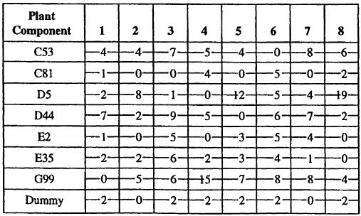

The following optimal assignments can now be made:
Assignments | Cost
Component G99 to Plant 1 | 0.55
Component E2 to Plant 2 | 0.07
Component C81 to Plant 3 | 0.04
Component D5 to Plant 4 | 0.30
Component D44 to Plant 5 | 0.10
Component C53 to Plant 6 | 0.06
Component E35 to Plant 8 |  | 0.06
Total Cost: | $1.18
Plant 7 will not be given a component.
15.26 | Job | Due Date | Duration (Days)
 | 010 | 260 | 30
 | 020 | 258 | 16
 | 030 | 260 | 8
 | 040 | 270 | 20
 | 050 | 275 | 10
(a) FCFS (first come, first served):
Because all jobs arrived on day 210, and presumably
in the order given, the FCFS sequence is:
010, 020, 030, 040, 050
(b) EDD (Earliest due date):
Job Sequence | Due Date
020 | 258
010 | 260
030 | 260
040 | 270
050 | 275
Note that the tie breaker of longest processing time was used; however, job 030 could come before job 010.
(c) SPT (shortest processing time):
Job Sequence | Processing Time
030 | 8
050 | 10
020 | 16
040 | 20
010 | 30
(d) LPT (longest processing time):
Job Sequence | Processing Time
010 | 30
040 | 20
020 | 16
050 | 10
030 | 8

 |  |  |  |  | Average
 |  |  |  |  | Number
Scheduling | Average |  |  | Average | of Jobs in
Rule | Tardiness |  |  | Flow Time | System
FCFS | (7.4) |  | 6.8 | 57.6 | 3.4
EDD | (7.4) |  | 6.8 | 54.8 | 3.3
SPT | (6.8) |  | 6.6 | 39.6 | 2.4
LPT | (12.6) |  | 12.0 | 61.2 | 3.6
If current time is 210.

15.27 | Job | Data Entry (Hours) | Verify (Hours)
 | A | 2.5 | 1.7
 | B | 3.8 | 2.6
 | C | 1.9 | 1.0
 | D | 1.8 | 3.0
Using Johnson’s Rule, the optimal sequence is:
D, B, A, C
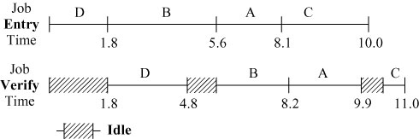
Case Study
OLD OREGON WOOD STORE
1. The assignment algorithm can be utilized to yield the fastest time to complete a table.
Person | Job | Time (Minutes)
Tom | Preparation | 100
Cathy | Assembly | 70
George | Finishing | 60
Leon | Packaging |  | 10
 | Total time | 240
2. If Randy is used, the assignment problem becomes unbalanced, and a dummy job must be added. The optimum assignment would be:
Person | Job | Time (Minutes)
George | Preparation | 80
Tom | Assembly | 60
Leon | Finishing | 80
Randy | Packaging |  | 10
 | Total time | 230
Cathy becomes the Backup.
3. If Cathy is given the preparation task, the solution of the assignment with the remaining three workers assigned to the remaining three tasks is:
Person | Job | Time (Minutes)
Cathy | Preparation | 120
Tom | Assembly | 60
George | Finishing | 60
Leon | Packaging |  | 10
 | Total time | 250
If Cathy is assigned to the finishing task, the optimum assign-ment is:
Person | Job | Time (Minutes)
George | Preparation | 80
Tom | Assembly | 60
Cathy | Finishing | 100
Leon | Packaging |  | 10
 | Total time | 250
4. One possibility would be to combine the packaging operation with finishing. Then George could build an entire table by himself (in 230 minutes), and Tom could do preparation (100 minutes), Randy the assembly (80 minutes), and Leon the finishing and packaging (90 minutes). This crew would build 4.8 tables in a 480-minute workday, while George himself could build 2.09 tables—a total of almost 7 tables per day.
To utilize all five workers, George and Tom could each build entire tables, 2.09 and 1.75 per day respectively. Letting Randy do preparation (110 minutes), Cathy the assembly (70 minutes), and Leon the finishing and packaging (90 minutes) allows an addi-tional 4.36 tables per day, for a total of 8.2 per day.
Nine tables per day could be achieved by having Tom prepare and assemble 3 tables, George prepare and finish 3 tables, Cathy assemble 6 tables, Leon finish 6 tables, and Randy prepare 3 tables and package all 9 tables. George, Cathy, and Randy would each have 60 minutes per day unutilized and could build 0.6 tables by having George do preparation (80 minutes), Cathy assembly and packaging (95 minutes), and Randy the finishing (100 minutes).
Video Case Study
SCHEDULING AT HARD ROCK CAFE
1. This case study works best if the 7-minute video, made specifically for this text, is shown and accompanies the written case.
Hoffman currently uses these factors in forecasting weekly cafe sales: (1) last year’s sales, (2) convention center data, (3) hotel occupancy rates, (4) concerts scheduled at Hard Rock Live. Other factors could include (1) weather forecasts (most tourists head home if a hurricane is bearing down on Florida and a rainy day will reduce sales), (2) concerts or major events at Universal Studios (which is adjacent to the cafe), (3) world events (since the restaurant is heavily tourist driven), (4) major events at the Citrus Bowl (football) or Waterhouse Arena that may bring large numbers of out-of-towners with them.
2. To lower turnover, Hard Rock tries to make schedules financially profitable to servers. It also provides a lot of flexibility in terms of shift preference. Further, the cafe provides a favorable working environment, where servers can “be themselves,” even if that means spiked, green hair and nose rings. At the end of 10 years of service, every Hard Rock employee receives a gold Rolex watch valued at over $10,000.
3. Seniority cuts down on turnover by rewarding employees who remain a longer time with an organization. Shift and service station are critical assignments, which can make a very big difference in income to a server.
4. By not overstaffing, the software increases employee produc-tivity. It also places senior servers at the busiest/hardest stations.
Additional Case Study*
PAYROLL PLANNING, INC.
The first step in tackling this case study is to translate the due
dates into minutes. Thus, for the monthly clients, the due dates are 9 × 60 = 540; for the biweekly clients, the due dates are 12 × 60 =
720; and for the weekly clients, the due dates are 15 × 60 = 900. The table shows the results of running Excel OM or POM for Windows under different processing rules.
 | Average
 | Number of
 | Jobs in | Average | Average
Rule | Systems | Flow Time | Lateness
Earliest due date (EDD) | 20.80 | 928 | 193
SPT | 12.03 | 537 | 135
Critical ratio | 22.82 | 1,018 | 273
It can be seen from the table that the rules that seem most intuitive work least well. The best rule seems to be shortest processing time (with its well-known advantages).

* This case study is located at our Companion Web site,
at www.pearsonhighered.com/heizer.

